A

Mini Project On

## A WEB-BASED PLATFORM TO ANALYSE & INSPECT OVER-ALL PERFORMANCE OF A STUDENT

(Submitted in partial fulfillment of the requirements for the award of Degree) BACHELOR OF TECHNOLOGY

In

COMPUTER SCIENCE AND ENGINEERING

By

M. VEDANGANA (197R1A05N3)

K. PRABHATH (197R1A05L9)

G.ALEKHYA (197R1A05L3)

Under the Guidance of

**Mrs. D. SANDHYA RANI**

(Assistant Professor)



## DEPARTMENT OF COMPUTER SCIENCE AND ENGINEERING CMR TECHNICAL CAMPUS

**UGC AUTONOMOUS**

#### (Accredited byNAAC, NBA, Permanently Affiliated to JNTUH, Approved by AICTE, New Delhi) Recognized Under Section 2(f) & 12(B) of the UGCAct.1956,

**Kandlakoya (V), Medchal Road, Hyderabad-501401.**

**2019-2023**

**DEPARTMENT OF COMPUTER SCIENCE AND ENGINEERING**



**CERTIFICATE**

This is to certify that the project entitled **“ A WEB-BASED PLATFORM TO ANALYSE & INSPECT OVER-ALL PERFORMANCE OF A STUDENT ”** being submitted by **M.VEDANGANA (197R1A05N3), K.PRABHATH (197R1A05L9)** and **G.ALEKHYA**

**((197R1A05L3)** in partial fulfillment of the requirements for the award of the degree of B.Tech in Computer Science and Engineering to the Jawaharlal Nehru Technological University Hyderabad, is a record of bonafide work carried out by them under our guidance and supervision during the year 2022-23.

The results embodied in this thesis have not been submitted to any other University or Institute for the award of any degree or diploma.

### Mrs. D. SANDHYA RANI

**(Assistant Professor) INTERNAL GUIDE**

### Dr. A. Raji Reddy DIRECTOR

**Dr. K. Srujan Raju HOD**

### EXTERNAL EXAMINER

**Submitted for viva voice Examination held on**

### ACKNOWLEDGEMENT

Apart from the efforts of us, the success of any project depends largely on the encouragement and guidelines of many others. We take this opportunity to express our gratitude to the people who have been instrumental in the successful completion of this project.

We take this opportunity to express my profound gratitude and deep regard to my guide

**D. Sandhya Rani,** Assistant Professor for her exemplary guidance, monitoring and constant encouragement throughout the project work. The blessing, help and guidance given by her shall carry us a long way in the journey of life on which we are about to embark.

We also take this opportunity to express a deep sense of gratitude to the Project Review Committee (PRC) **Dr. Punyaban Patel, Ms. Shilpa, Dr. M. Subha Mastan Rao & J. Narasimha Rao** for their cordial support, valuable information and guidance, which helped us in completing this task through various stages.

We are also thankful to **Dr. K. Srujan Raju,** Head, Department of Computer Science and Engineering for providing encouragement and support for completing this project successfully.

We are obliged to **Dr. A. Raji Reddy,** Director for being cooperative throughout the course of this project. We also express our sincere gratitude to Sri. **Ch. Gopal Reddy,** Chairman for providing excellent infrastructure and a nice atmosphere throughout the course of this project.

The guidance and support received from all the members of **CMR Technical Campus** who contributed to the completion of the project. We are grateful for their constant support and help.

Finally, we would like to take this opportunity to thank our family for their constant encouragement, without which this assignment would not be completed. We sincerely acknowledge and thank all those who gave support directly and indirectly in the completion ofthis project.

#### M. VEDANGANA (197R1A05N3)

**K. PRABHATH (197R1A05L9)**

**G.ALEKHYA (197R1A05L3)**

### ABSTRACT

This project is a website which decides Student of the year for a particular academic year based on overall performance of the student. The Student of the year is selected based on their academic CGPA, attendance and active participation in co-curricular activities. The academic CGPA must be minimum of 6.0 with no active backlogs, attendance must be an average of 75% and the student must participate at least in 3 or more co-curricular activities. This project helps in overall improvement of a student performance, which encourages and motivates a student to actively participate in co-curricular activities apart from academics. The competitive spirit helps in maintaining good CGPA and overall attendance. We encourage students by providing them with certificates and presenting the winner with a trophy and the title “STUDENT OF THE YEAR”. It also improves the interaction between students and clubs to have knowledge about the events happening in and around the college.

### LIST OF FIGURES/TABLES

**FIGURE NO FIGURE NAME PAGE NO**

Figure 3.1:

Figure 3.2 :

Figure 3.3 :

Figure 3.4 :

Figure 3.5 :

Project Flow Chart Architecture

to analyse and inspect over all 7

performance of a student.

Use Case Diagram to analyse

and inspect over all performance 8

of a student.

Class Diagram to analyse and

inspect over all performance of a 9

student.

Sequence Diagram to analyse and

inspect over all performance of a 10

student.

Activity Diagram to analyse and

inspect over all performance of a 11

student.

## RESULTS

### SCREENSHOT NO.

Screenshot 5.1

### SCREENSHOT NAME.

SOTY Main Page

**PAGE NO**.

16

Screenshot 5.2

Screenshot 5.3

Screenshot 5.4

Key Takeaways 17

Winners of SOTY 18

Top 10 finalist of 3rd years 19

Screenshot 5.5

Screenshot 5.6

Top 10 finalist of 2rd years 20

About Clubs 21

Screenshot 5.7 About Events 22

### ABSTRACT

**TABLE OF CONTENTS**

i

### LIST OF FIGURES/ TABLES RESULTS

1. **INTRODUCTION**
   1. PROJECT SCOPE
   2. PROJECT PURPOSE
   3. PROJECT FEATURES

### SYSTEM ANALYSIS

* 1. PROBLEM DEFINITION
  2. EXISTING SYSTEM
     1. LIMITATIONS OF THE EXISTING SYSTEM
  3. PROPOSED SYSTEM
     1. ADVANTAGES OF PROPOSED SYSTEM
  4. FEASIBILITY STUDY
     1. ECONOMIC FEASIBILITY
     2. TECHNICAL FEASIBILITY
     3. BEHAVIOURAL FEASIBILITY
  5. HARDWARE & SOFTWARE REQUIREMENTS
     1. HARDWARE REQUIREMENTS
     2. SOFTWARE REQUIREMENTS

### ARCHITECTURE

* 1. PROJECT ARCHITECTURE
  2. DESCRIPTION
  3. USE CASE DIAGRAM
  4. CLASS DIAGRAM
  5. SEQUENCE DIAGRAM
  6. ACTIVITY DIAGRAM

### IMPLEMENTATION

* 1. SAMPLE CODE

1. **RESULTS**

ii iii 1

1

1

1

2

2

2

2

3

3

4

4

5

5

5

5

6

7

7

8

8

9

10

11

12

12

16

1. TESTING 23
   1. INTRODUCTION TO TESTING 23
   2. TYPES OF TESTING 23
      1. UNIT TESTING 23
      2. INTEGRATION TESTING 24
      3. FUNCTIONAL TESTING 24
   3. TEST CASES 25
      1. CLASSIFICATION 25
2. CONCLUSION & FUTURE SCOPE 26
   1. PROJECT CONCLUSION 26
   2. FUTURE SCOPE 26
3. BIBLIOGRAPHY 27
   1. REFERENCES 27
   2. GITHUB LINK 27

# INTRODUCTION

## INTRODUCTION

### PROJECT SCOPE

This project is titled "A web based platform to analyse and inspect overall performance of a student". This project is a website, it involves by deciding the student of the year for a particular academic year based on overall performance of the student. The project mainly focuses on the overall improvement of the student's performance. It provides proper recognition to the student, events and clubs.

### PROJECT PURPOSE

This project has been developed to decide student of the year for a particular year. The Student of the year is selected based on their academic CGPA, attendance and active participation in co-curricular activities. This project helps in overall improvement of a student performance and motivates the student to actively participate in co-curricular activities apart from academics.

### PROJECT FEATURES

The main feature of this project is to showcase the students talent in different aspects. This helps in updating the student’s progress with the help of leader board by collecting the data from students and college. The competitive spirit helps in maintaining good CGPA and overall attendance. We encourage students by providing them with certificates and presenting the winner with a trophy and the title “STUDENT OF THE YEAR”.

# SYSTEM ANALYSIS

## SYSTEM ANALYSIS

### SYSTEM ANALYSIS

System Analysis is the important phase in the system development process. The System is studied to the minute details and analyzed. The system analyst plays an important role of an interrogator and dwells deep into the working of the present system. In analysis, a detailed study of these operations performed by the system and their relationships within and outside the system is done. A key question considered here is, “what must be done to solve the problem?” The system is viewed as a whole and the inputs to the system are identified. Once analysis is completed the analyst has a firm understanding of what is to be done.

### PROBLEM DEFINITION

A general statement of Student of the year is given on the basis of his /her overall performance of a student. The information stored in system database is verified and analyzed by the admin. It encourages the student to actively participate in co-curricular activities and motivates the student in maintaining good attendance and CGPA.

### EXISTING SYSTEM

Since this is a very first project in our college, there are no existing systems. We created this based on our college rules and regulations which can help the student to perform well in all aspects like studies, attendance, co-curricular activities, etc. We took few websites for an idea to improve our design and performance of the website.

#### DISADVANTAGES OF EXISTING SYSTEM

Following are the disadvantages of existing system: We cannot collect all the data from students.

Few eligible and not interested students cannot be awarded as the Student of the year.

### PROPOSED SYSTEM

We proposed a website where it helps students to showcase their talents in different aspects. It monitors each and every aspect of the student like attendance, CGPA and number of events participated in an academic year. This helps in updating the student’s progress with the help of leader board by collecting the data from students and college. This website is further controlled by the college management where the all the data is secured.

#### ADVANTAGES OF THE PROPOSED SYSTEM

Following are the advantages of the proposed system:

Motivates the students to maintain proper attendance. Builds up the competitive spirit among the students.

Encourages the students to study well and to maintain no backlogs. Get proper recognition to students, events and clubs.

Helps in overall improvement of student performance.

### FEASIBILITY STUDY

The feasibility of the project is analyzed in this phase and a business proposal is put forth with a very general plan for the project and some cost estimates. During system analysis the feasibility study of the proposed system is to be carried out. This is to ensure that the proposed system is not a burden to the company. Three key considerations involved in the feasibility analysis:

Economic Feasibility Technical Feasibility Social Feasibility

#### ECONOMIC FEASIBILITY

The developing system must be justified by cost and benefit. Criteria to ensure that effort is concentrated on a project, which will give best, return at the earliest. One of the factors, which affect the development of a new system, is the cost it would require.

The following are some of the important financial questions asked during preliminary investigation:

The costs conduct a full system investigation. The cost of the hardware and software.

The benefits in the form of reduced costs or fewer costly errors.

Since the system is developed as part of project work, there is no manual cost to spend for the proposed system. Also all the resources are already available, it give an indication that the system is economically possible for development.

#### TECHNICAL FEASIBILITY

This study is carried out to check the technical feasibility, that is, the technical requirements of the system. Any system developed must not have a high demand on the available technical resources. The developed system must have a modest requirement, as only minimal or null changes are required for implementing this system.

#### BEHAVIORAL FEASIBILITY

This includes the following questions:

Is there sufficient support for the users? Will the proposed system cause harm?

The project would be beneficial because it satisfies the objectives when developed and installed. All behavioral aspects are considered carefully and conclude that the project is behaviorally feasible.

### HARDWARE & SOFTWARE REQUIREMENTS

#### HARDWARE REQUIREMENTS:

Hardware interfaces specify the logical characteristics of each interface between the software product and the hardware components of the system. The following are some hardware requirements.

Laptop/System Documentation Camera

Prizes & certificates Wi-Fi

#### SOFTWARE REQUIREMENTS:

Software Requirements specifies the logical characteristics of each interface and software components of the system. The following are some software requirements:

VS Code

MS Office/Notepad Bootstrap

Google Chrome

# ARCHITECTURE

## ARCHITECTURE

### PROJECT ARCHITECTURE

This project architecture shows the procedure followed for classification, starting from input to final output.

Start

Student

Student registration

Gathers student information

Performance analysis

HTML CSS JS

SOTY

website

End

Winner

Figure 3.1: Project Flow Chart Architecture to analyse and inspect over all performance of a student.

### DESCRIPTION

This project is totally based upon deciding Student of the year for a particular academic year based on overall performance of the student. It helps in overall improvement of a student performance, which encourages and motivates a student to actively participate in co-curricular activities apart from academics. The competitive spirit helps in maintaining good CGPA and overall attendance. We encourage students by providing them with certificates and presenting the winner with a trophy and the title “STUDENT OF THE YEAR”. It also improves the interaction between students and clubs to have knowledge about the events happening in and around the college.

### USE CASE DIAGRAM

In the use case diagram, we have basically one actor who is the user in the trained model. A use case diagram is a graphical depiction of a user's possible interactions with a system. A use case diagram shows various use cases and different types of users the system has. The use cases are represented by either circles or ellipses. The actors are often shown as stick figures.

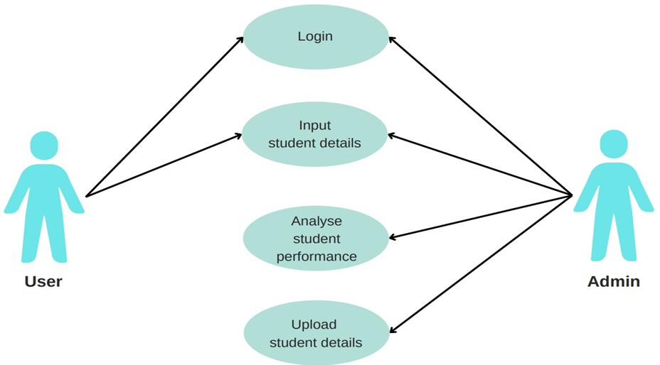

Figure 3.3: Use Case Diagram to analyse and inspect over all performance of a student.

### CLASS DIAGRAM

Class diagram is a type of static structure diagram that describes the structure of a system by showing the system’s classes, their attributes, operations (or methods), and the relationships among objects.

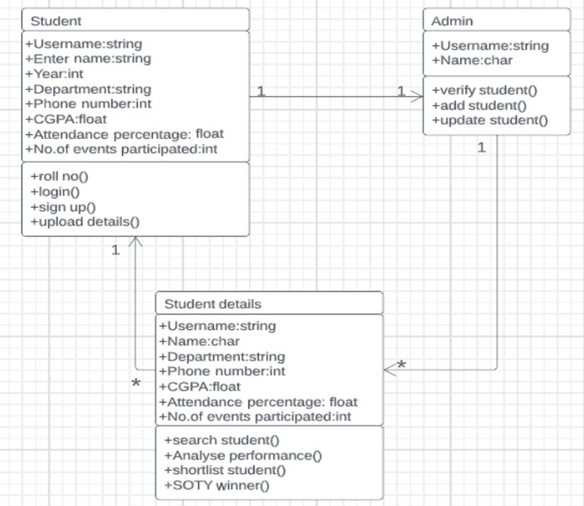

Figure 3.4: Class Diagram to analyse and inspect over all performance of a student.

### SEQUENCE DIAGRAM

A sequence diagram shows object interactions arranged in time sequence. It depicts the objects involved in the scenario and the sequence of messages exchanged between the objects needed to carry out the functionality of the scenario. Sequence diagrams are typically associated with use case realizations in the logical view of the system under development.

: student : website : web server : Admin : DB

2.Request register page()



1.Click on

register tab()

4.Display

Register field()

5.Enter

information()

6.Click

submit button()

11.ReEnter

information()

14.Send acceptance email()



..................................................................

..................................................................

..................................................................

..................................................................

..................................................................

3.Return register page()

* + - * 1. Send new student information()
        2. Verify new student information()

9.Invalid

new student()

10.Send

errors()

1. Valid new student()

13.Save()

    

Figure 3.5: Sequence Diagram to analyse and inspect over all performance of a student.

### ACTIVITY DIAGRAM

Activity diagrams are graphical representations of workflows of stepwise activities and actions with support for choice, iteration and concurrency. They can also include elements showing the flow of data between activities through one or more data stores.



Enter Student roll no

Enter year & dept

Enter CGPA

No

Yes

Enter attendence percentage

No

Yes Enter no.of events

participated

Yes

He/she is

eligible

No

SOTY

winner

Figure 3.6: Activity Diagram to analyse and inspect over all performance of a student.

# IMPLEMENTATION

### 4.1 SAMPLE CODE

<!DOCTYPE html>

<html lang="en">

<head>

<meta charset="utf-8">

<meta name="viewport" content="width=device-width, initial-scale=1, shrink-to-fit=no">

<!-- SEO Meta Tags -->

<meta name="description"

content="Landing page template built with HTML and Bootstrap 4 for presenting training courses, classes, workshops and for convincing visitors to register using the form.">

<meta name="author" content="Inovatik">

<!-- OG Meta Tags to improve the way the post looks when you share the page on LinkedIn, Facebook, Google+ -->

<meta property="og:site_name" content="" /> <!-- website name -->

<meta property="og:site" content="" /> <!-- website link -->

<meta property="og:title" content="" /> <!-- title shown in the actual shared post -->

<meta property="og:description" content="" /> <!-- description shown in the actual shared post -->

<meta property="og:image" content="" /> <!-- image link, make sure it's jpg -->

<meta property="og:url" content="" /> <!-- where do you want your post to link to -->

<meta property="og:type" content="article" />

<!-- Website Title -->

<title>SOTY - Student Of The Year</title>

<!-- Styles -->

<link href="https://fonts.googleapis.com/css?

family=Montserrat:400,400i,600,700,700i&display=swap" rel="stylesheet">

<link href="css/bootstrap.css" rel="stylesheet">

<link href="css/fontawesome-all.css" rel="stylesheet">

<link href="css/swiper.css" rel="stylesheet">

<link href="css/magnific-popup.css" rel="stylesheet">

<link href="css/styles.css" rel="stylesheet">

<script src="https://kit.fontawesome.com/yourcode.js" crossorigin="anonymous"></script>

<!-- Favicon -->

<link rel="icon" href="images/transparent.png">

</head>

<body data-spy="scroll" data-target=".fixed-top">

<!-- Preloader -->

<div class="spinner-wrapper">

<div class="spinner">

<div class="bounce1"></div>

<div class="bounce2"></div>

<div class="bounce3"></div>

</div>

</div>

<!-- end of preloader -->

<!-- Navigation -->

<nav class="navbar navbar-expand-lg navbar-dark navbar-custom fixed-top">

<!-- Text Logo - Use this if you don't have a graphic logo -->

<!-- <a class="navbar-brand logo-text page-scroll" href="index.html">Corso</a> -->

<!-- Image Logo -->

<a class="navbar-brand logo-image" href="index.html"><img src="images/soty logo.png" alt="alternative"></a>

<a class="navbar-brand logo-image" href="index.html"><img src="images/SOTY.png" alt="alternative"></a>

<!-- Mobile Menu Toggle Button -->

<button class="navbar-toggler" type="button" data-toggle="collapse" data target="#navbarsExampleDefault"

aria-controls="navbarsExampleDefault" aria-expanded="false" aria-label="Toggle navigation">

<span class="navbar-toggler-awesome fas fa-bars"></span>

<span class="navbar-toggler-awesome fas fa-times"></span>

</button>

<!-- end of mobile menu toggle button -->

<div class="collapse navbar-collapse" id="navbarsExampleDefault">

<ul class="navbar-nav ml-auto">

<li class="nav-item">

<a class="nav-link page-scroll" href="#register">REGISTER <span class="sr- only">(current)</span></a>

</li>

<li class="nav-item">

<a class="nav-link page-scroll" href="#description">LEADER BOARD</a>

</li>

<!-- Dropdown Menu -->

<li class="nav-item dropdown">

<a class="nav-link dropdown-toggle page-scroll" href="#date" id="navbarDropdown" role="button"

aria-haspopup="true" aria-expanded="false">EVENTS</a>

<div class="dropdown-menu" aria-labelledby="navbarDropdown">

<a class="dropdown-item" href="clubs.html"><span class="item-text">ABOUT CLUBS</span></a>

<div class="dropdown-divider"></div>

<a class="dropdown-item" href="events.html"><span class="item-text">ABOUT EVENTS</span></a>

<div class="dropdown-divider"></div>

<a class="dropdown-item" href="terms-conditions.html"><span class="item- text">TERMS & CONDITIONS</span></a>

</div>

</li>

<!-- end of dropdown menu -->

# RESULTS

## RESULTS

This project is a website, it involves in deciding the student of the year for a particular academic year based on overall performance of the student. The main page of “STUDENT OF THE YEAR” looks like where in we can see the SOTY logo, register button, leader board button, events button, our team button, contact button and mail icon on the nav bar which directs to that specific page when clicked on them. The picture shows the team members who created the website.

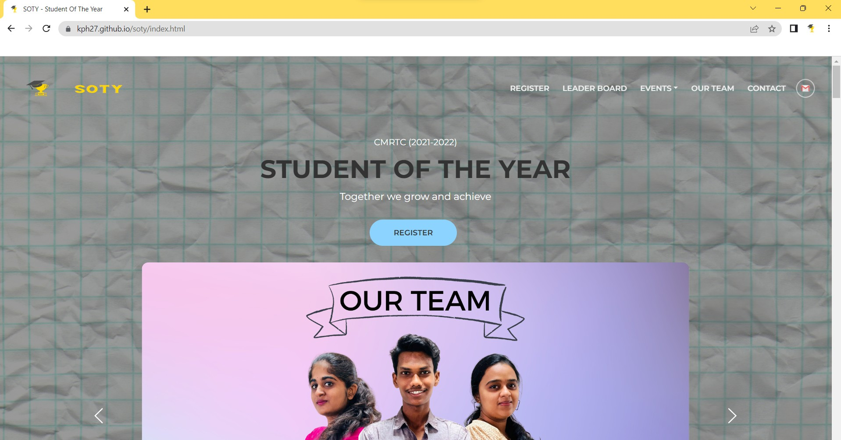

Screenshot 5.1: SOTY Main Page

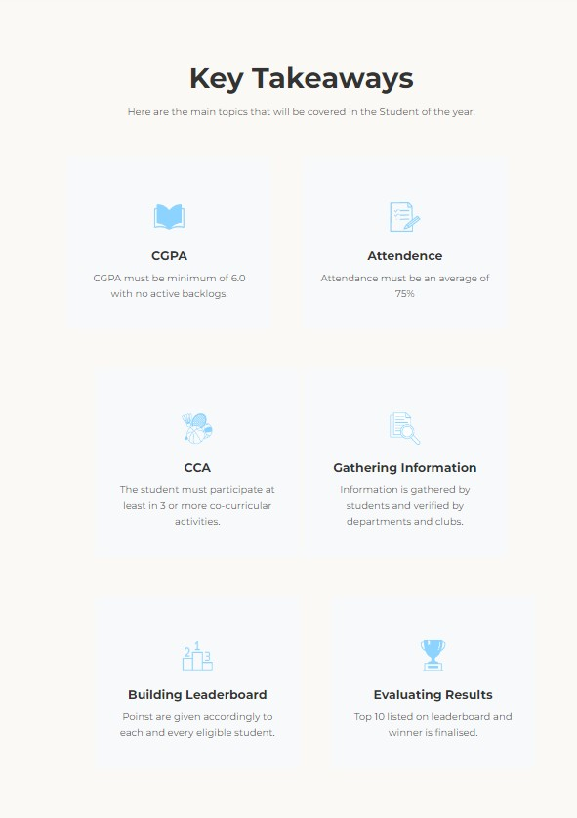The main topics covered in the Student of the year which are showed in the homepage of our website, which are CGPA, Attendance, CCA, Gathering Information, Building Leaderboard & Evaluating Results.

Screenshot 5.2: Key Takeaways

The below picture shows the winners of the academic year 2021-2022 from second and third years for the department of Computer Science and Engineering. The winner is selected based on their academic CGPA, attendance and active participation in co-curricular activities. The winners are Gaurav Mandal (197R1A05L1) from third year and Suryabhasker.K (207R1A0522) from second year.

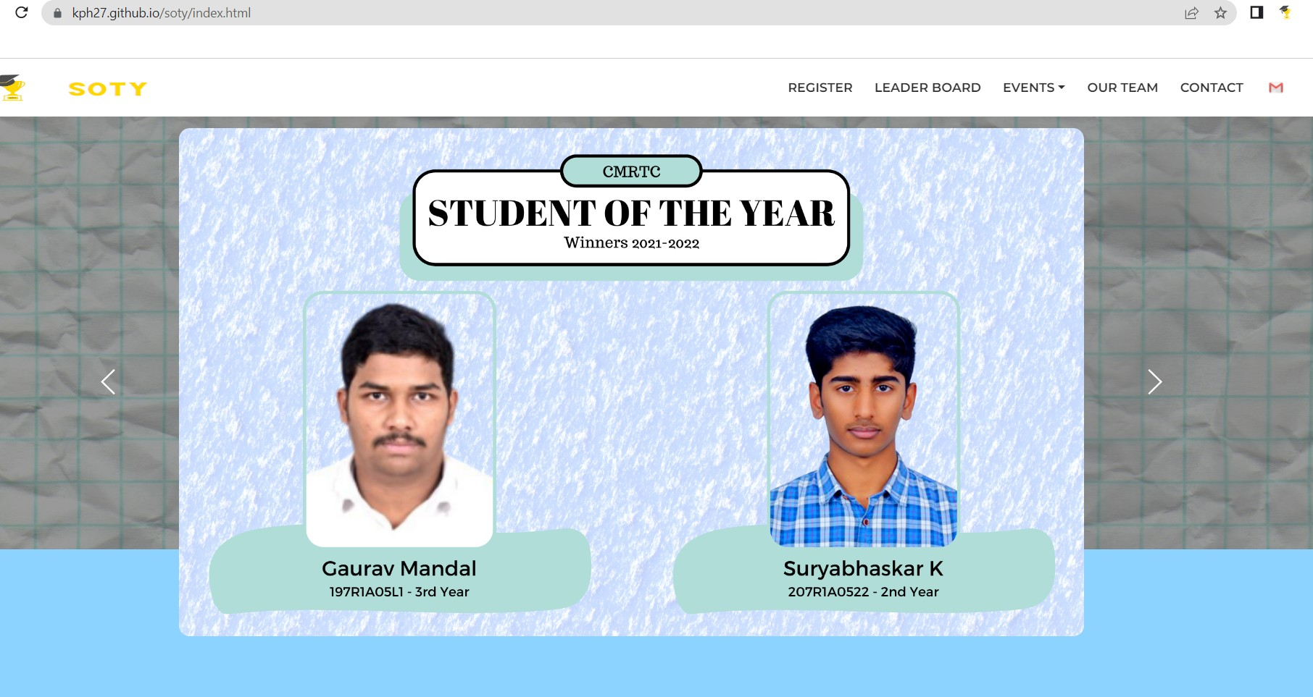

Screenshot 5.3: Winners of SOTY

The below picture shows the top 10 finalist from third years of the academic year 2021-

2022.

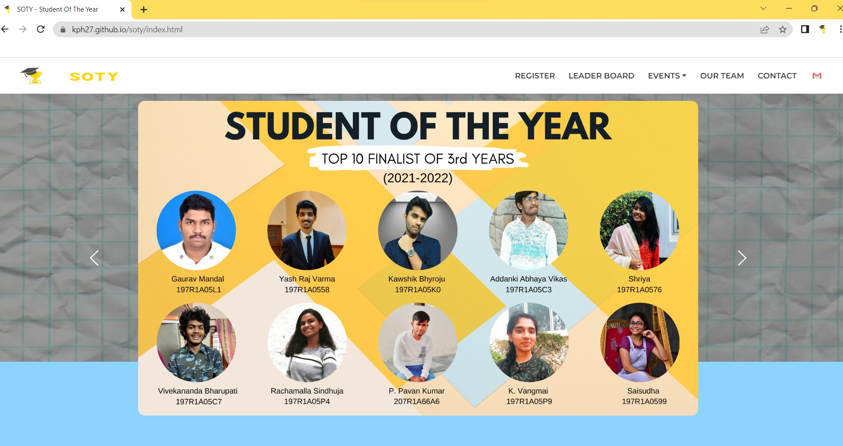

Screenshot 5.4: Top 10 finalist of 3rd years

The below picture shows the top 10 finalist from second years of the academic year 2021-

2022.

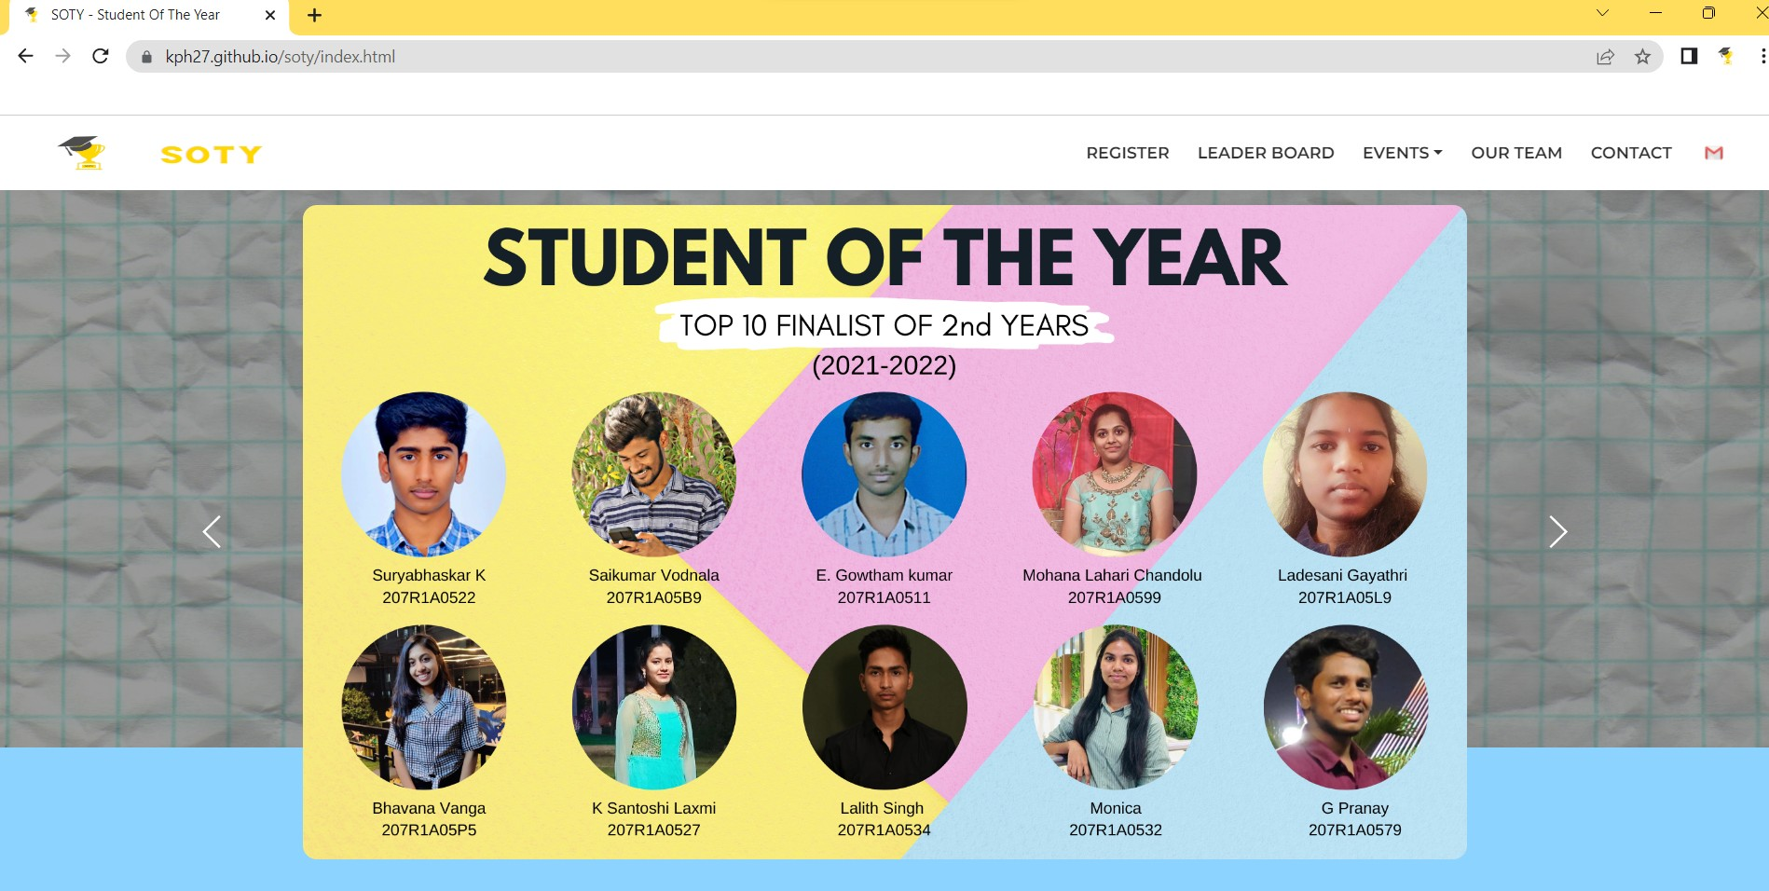

Screenshot 5.5: Top 10 finalist of 2rd years

It helps the students to know the different types of clubs present in our college and motivates the student to actively participate in co-curricular activities apart from academics. The below page has been created to showcase the types of clubs in our college. By clicking on the club name we will be directed directly to the main page of the club which has all the information about that particular club which is present in our college official website.

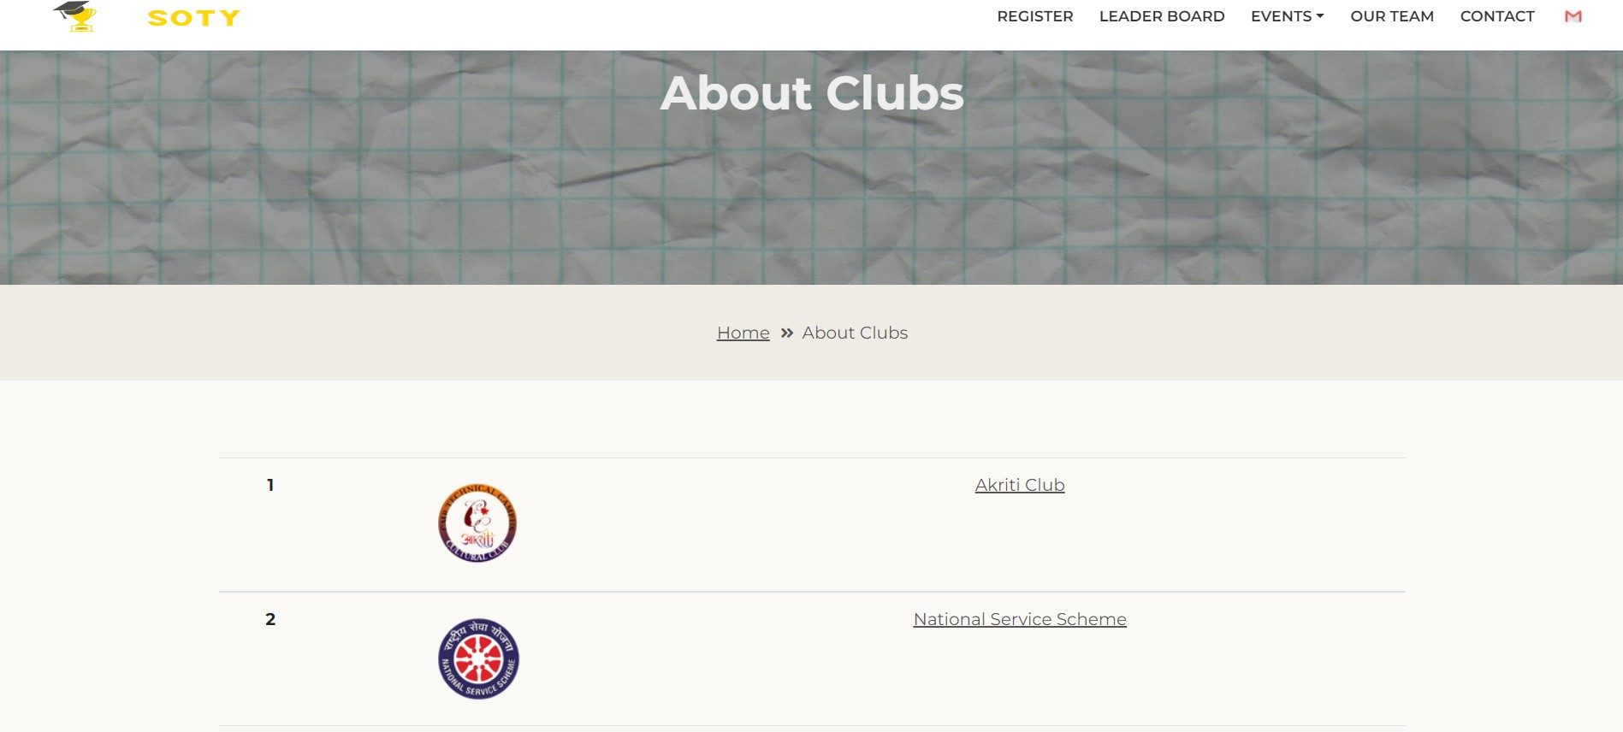

Screenshot 5.6: About Clubs

The below page has been created to let the students know what all events are conducted by the clubs followed by the event dates.

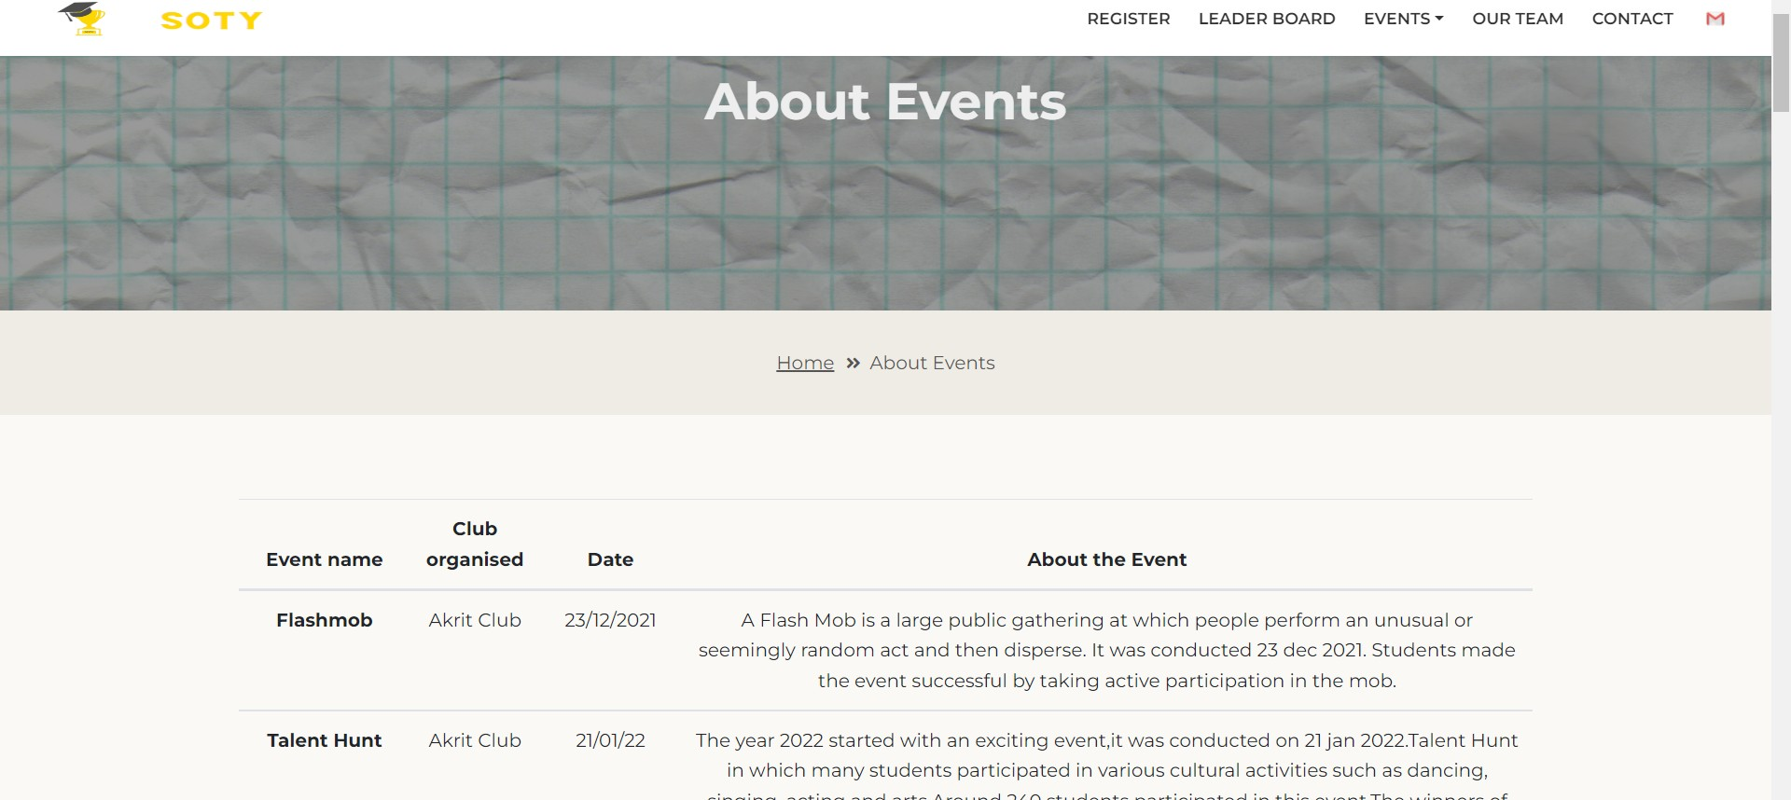

Screenshot 5.7: About Events

# TESTING

## TESTING

### INTRODUCTION TO TESTING

The purpose of testing is to discover errors. Testing is the process of trying to discover every conceivable fault or weakness in a work product. It provides a way to check the functionality of components, subassemblies, assemblies and/or a finished product. It is the process of exercising software with the intent of ensuring that the Software system meets its requirements and user expectations and does not fail in an unacceptable manner. There are various types of tests. Each test type addresses a specific testing requirement.

### TYPES OF TESTING

#### UNIT TESTING

Unit testing involves the design of test cases that validate that the internal program logic is functioning properly, and that program inputs produce valid outputs. All decision branches and internal code flow should be validated. It is the testing of individual software units of the application .It is done after the completion of an individual unit before integration. This is a structural testing that relies on knowledge of its construction and is invasive. Unit tests perform basic tests at component level and test a specific business process, application and/or system configuration. Unit tests ensure that each unique path of a business process performs accurately to the documented specifications and contains clearly defined inputs and expected results.

#### INTEGRATION TESTING

Integration tests are designed to test integrated software components to determine if they actually run as one program. Integration tests demonstrate that although the components were individually satisfactory, as shown by successfully unit testing, the combination of components is correct and consistent. Integration testing is specifically aimed at exposing the problems that arise from the combination of components.

#### FUNCTIONAL TESTING

Functional tests provide systematic demonstrations that functions tested are available as specified by the business and technical requirements, system documentation, and user manuals.

Functional testing is centered on the following items:

Valid Input : identified classes of valid input must be accepted. Invalid : identified classes of invalid input must Input be rejected. Functions : identified functions must be exercised.

Output : identified classes of application outputs must be exercised.

Systems/Procedures: Interfacing systems or procedures must be invoked. Organization and preparation of functional tests is focused on requirements, key functions, or special test cases.

### TEST CASES

#### CLASSIFICATION

|  |  |  |  |  |
| --- | --- | --- | --- | --- |
| Test case ID | Test case name | Purpose | Input | Output |
| 1 | User login | To participate in student of the year contest | The user will login with the credentials. | The user can fill his details in goggle form. |
| 2 | Admin login | To approve the request and decide the student of the year. | The admin will | The student of the |
| year is decided and uploaded on the leader board. |
| login and approve the request from user to upload the student details. |

# CONCLUSION

### CONCLUSION & FUTURE SCOPE

### PROJECT CONCLUSION

The potential benefit of using the project "A web based platform to analyse and inspect the overall performance of a student" is, it mainly focuses on the overall improvement of a student’s performance which is designed to serve the purpose of providing proper recognition to the student, events and clubs. This project can be used in other sectors as well like tracking attendance, CGPA, events performed and clubs organized. It helps in monitoring student activities. It can be extended throughout the college/university/board.

### FUTURE SCOPE

The potential idea behind the idea of the project is, we completed this project based on our college rules and regulations. Further more new rules can be added. We have completed this project by considering only 2nd and 3rd year students from the department of computer science & engineering. Further this can be considered for overall campus/university. By this every student will be motivated and we can see improvement in overall performance of the student. This can be added to the official college website so that the student access to this contest easily, even the new people who are opening the college website will know about this "Student of the year".

# BIBLIOGRAPHY

### 8. BIBLIOGRAPHY

### REFERENCES

* + 1. HTML & CSS: The Complete Reference, Fifth Edition, 1 July 2017 by Thomas Powell (Author).
    2. JavaScript: The Complete Reference, 2nd edition (Osborne Complete Reference Series), 16 July 2004 by Thomas Powell (Author), Fritz Schneider (Author).
    3. Visual Studio Code: Visual Studio Code by Bruce Johnson, Released September 2019, Publisher(s): Wiley.
    4. Github: Pro Git book, written by Scott Chacon and Ben Straub and published by Apress, 2nd Edition (2014).
    5. Canva: Professional Tips and Tricks When You Design with Canva (Step by Step Canva Guide for Work or Business with Pictures) by Patrick Ejeke, 2021.
    6. Microsoft Office: Learn Microsoft Office 2019: A comprehensive guide to getting started with Word, PowerPoint, Excel, Access, and Outlook, 29 May 2020, by Linda Foulkes.
    7. Filmora: A Beginners Guide To Filmora 9, Bryson Sim, Lulu.com, 20- Feb-2020.

### GITHUB LINK

https://github.com/kph27/soty